

MARLBOROUGH TOWN COUNCIL

JOIN US AS A TOWN COUNCILLOR

Co-option Process
If you would like to make a difference and represent your community, why not consider becoming a Town Councillor? Following the resignation of Peter Morgan there is a vacancy for a Town Councillor in Marlborough’s West Ward. The Town Council can now co-opt someone to this position.

Interested? Here’s what you need to know:

Do I qualify?
Firstly, you will need to confirm that you qualify. So, this means you need to be:
- At least 18 years old
- A British citizen, an eligible Commonwealth citizen, a citizen of the Republic of Ireland, a qualifying EU citizen or an EU citizen with retained rights
- And you must meet at least one of the following four qualifications:
- You are, and will continue to be, registered as a local government elector for the parish in which you wish to stand from the day of your application onwards.
- You have occupied as owner or tenant any land or other premises in the parish area during the whole of the 12 months before the day of your application and the day of co-option.
- Your main or only place of work during the 12 months prior to the day of your application and the day of co-option has been in the parish area.
- You have lived in the parish area or within three miles of it during the whole of the 12 months before the day of your application and the day of co-option

Certain people are unable to stand, and these include paid officers of the council, those subject to bankruptcy orders and those subject to recent sentences of imprisonment. (More details are set out on the co-option form)

For more details about the above see the Electoral Commission website.

What is the next step?
Complete a co-option form confirming that you qualify and send us a written statement (no more than one side of A4) setting out why you would like to serve as a Councillor and what attributes you could bring to the role.

Your statement will be included in the public agenda papers for the Full Town Council meeting on Monday, 7 September when our Councillors will select (co-opt) a new Councillor. The deadline to confirm that you qualify and submit your written statement is 4pm on Friday, 21 August 2026.

How will candidates be selected?
At the meeting you will be asked to make a short presentation explaining why you wish to become a Councillor (no more than 3-5 minutes) after which Town Councillors will ask you questions.

After this Councillors will vote for their preferred candidate. You will be informed of the outcome immediately afterwards or as soon as possible the following day.

Is there anything else I need to know?
Please feel free to contact Richard Spencer-Williams, the Town Clerk, to arrange a chat about the Town Council and its committees and the role of a Town Councillor. It’s worth having a look at our website at www.marlborough-tc.gov.uk and having a browse through previous meeting minutes too.
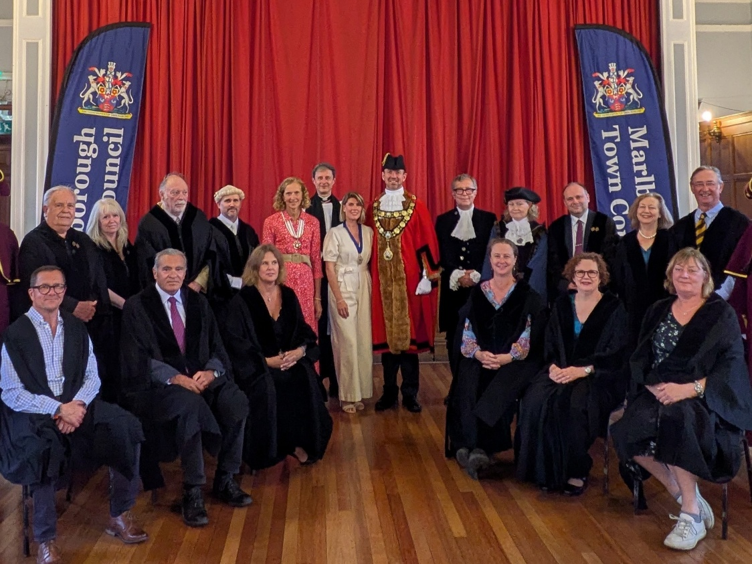

The Town Mayor, Councillor Mark Luson, and Marlborough Town Councillors look forward to meeting you

June 2026



Co-option Eligibility Form

To be eligible for co-option as a Marlborough Town Councillor you must be (1) a British citizen, an eligible Commonwealth citizen, a citizen of the Republic of Ireland, a qualifying EU citizen or an EU citizen with retained rights; (2) 18 years of age or over and (3) able to meet at least one of the following qualifications set out below. Please mark all that apply as appropriate -

I am registered as a local government elector for the parish of Marlborough
I have, during the whole twelve months preceding the date of co-option, occupied (as owner or tenant) land or other premises in the parish
My principal or only place of work during those twelve months has been in the parish
I have, during the whole of the past twelve months, lived in the parish or within 3 miles of it

As long as you meet at least one of the criteria above, you may apply for co-option.

There are some people who are disqualified from being a Councillor. You cannot become a Councillor if –

  - You are employed by the parish/town council
  - You are the subject of a bankruptcy restrictions order or interim order
  - You have been sentenced to a term of imprisonment for three months or more (including a suspended sentence), without the option of a fine, during the previous five years
  - You have been disqualified under the Representation of the People Act 1983 (which covers corrupt or illegal electoral practices and offences relating to donations).

I (insert name) _________________________________________ confirm that I am eligible to apply for the vacancy of Marlborough Town Councillor and the information given on this form is a true and accurate record.

Signed ____________________________________________________ Dated _______________________

PTO

Please add your contact details so we can get in touch.

Phone

Email

Address

Send your completed form and statement to arrive before 4pm on Friday 21 August to:
townclerk@marlborough-tc.gov.uk
or

Marked ‘Private and Confidential’ by post to Richard Spencer-Williams, Town Clerk, Marlborough Town Council, 5 High Street, Marlborough SN8 1AA

https://www.electoralcommission.org.uk/guidance-candidates-parish-council-elections-england/what-you-need-know-you-stand-a-candidate/qualifications-and-disqualifications-standing-election/qualifications

